**1. Project Abstract**



**ABSTRACT**

The Railway Ticket Booking System is an application developed to simplify and streamline the ticket booking process for passengers. This system, developed in C, manages and stores all the booking-related data in an efficient manner, ensuring a reduction in errors and time-consuming tasks that were common in manual systems. The primary goal of this system is to provide a reliable, secure, and user-friendly platform for booking railway tickets.

The system has two types of logins: Administrator and Client. The administrator manages the overall system operations, including client data, ticket bookings, and access control. The client, on the other hand, can register and book tickets by selecting destinations, coach types, and other preferences.

This system was created to address issues like data redundancy, difficulty in handling multiple files, and inefficiencies in manual ticket booking processes. It offers secure access to sensitive information, with only the administrator having the authority to modify or update data. The client can view and manage their booking details through their login.

The system ensures accurate data handling and eliminates the need for redundant entries, offering a smooth experience for users. By automating the process of ticket booking, the system is more reliable and reduces the chances of errors, providing a more efficient and organized way to manage bookings.

**2. Objectives**



**Objectives:**

The primary objective of a Railway Ticket Booking System is to simplify and automate the process of booking train tickets, making it more efficient and user-friendly. It aims to reduce the complexities associated with manual booking and provide a smooth experience for both passengers and administrators. Here’s a breakdown of its goals:

* Efficient Ticket Booking Process
* Revenue Management
* Reduces Communication Gaps
* Destination and Coach Management
* Passenger Information Handling
* Organizes and Simplifies Booking Tasks
* Centralized Data and Easy Access

**3. Software Specification**



**Software Specification**

|  |  |
| --- | --- |
| Language | C Language |
| Operation System | Windows 11 |
| Tools | Dev C++ |

**4. Database Design / File System (Table Design)**



**Admin Database Design:**

|  |  |
| --- | --- |
| **Admin Register** | **Admin Login** |
| Admin Full Name | Admin Email Id |
| Admin Contact Number | Admin Password |
| Admin Address |  |
| Admin Email Id |  |
| Admin Password |  |
| Admin Repeat Password |  |

**User Database Design:**

|  |  |
| --- | --- |
| **User Register** | **User Login** |
| User Full Name | User Email Id |
| User Contact Number | User Password |
| User Address |  |
| User Email Id |  |
| User Password |  |
| User Repeat Password |  |

**Ticket Booking Database Design:**

|  |
| --- |
| Tourist Name |
| Tourist Age |
| Select Destination |
| Select Coach [AC & Non-AC] |
| Select Food [Veg & Non-Veg] |
| Counts of Tickets |
| Show Ticket Price |
| Payment Process |
| Payments Amount |
| Payment Id |
| Payment Process |

**5. Diagrams**



**Use Case Diagram:**

**5.1 Admin Use Case Diagram**

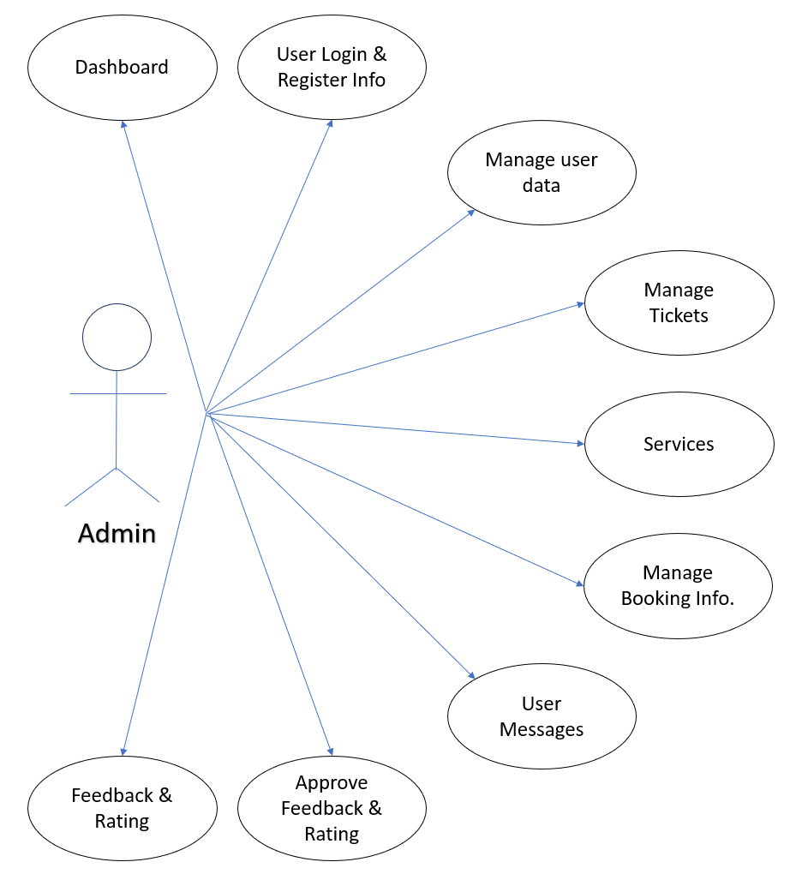

**[Admin Use Case Diagram]**

**5.2 User Use Case Diagram:**

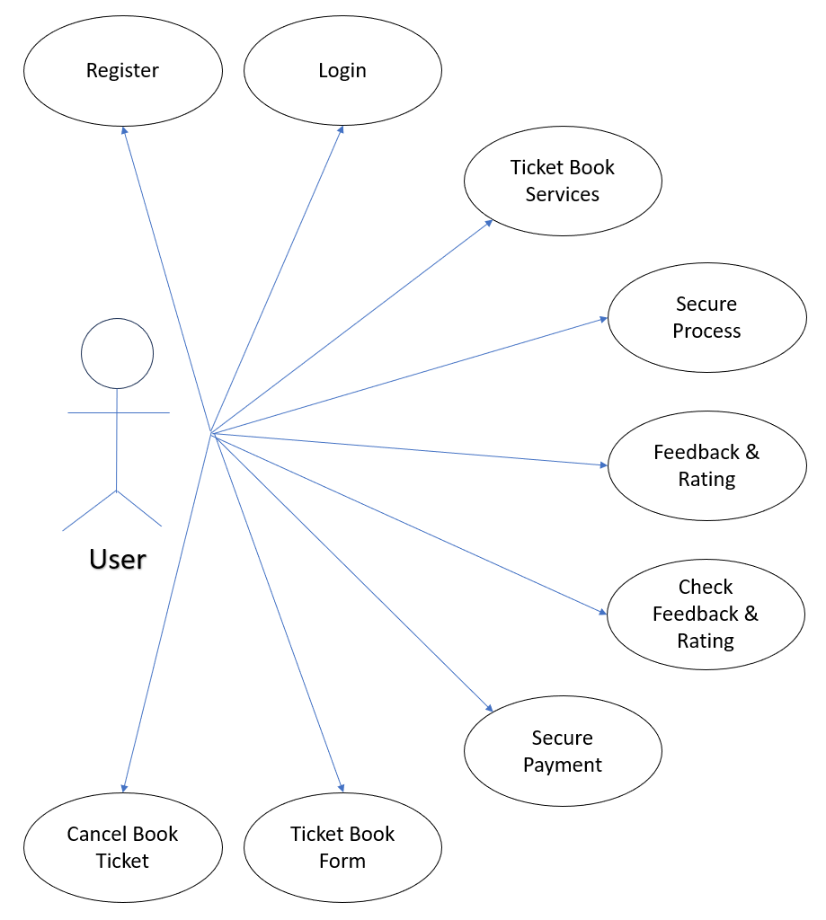

**[User Use Case Diagram]**

**Activity Diagram:**

**5.3 Admin Activity Diagram:**

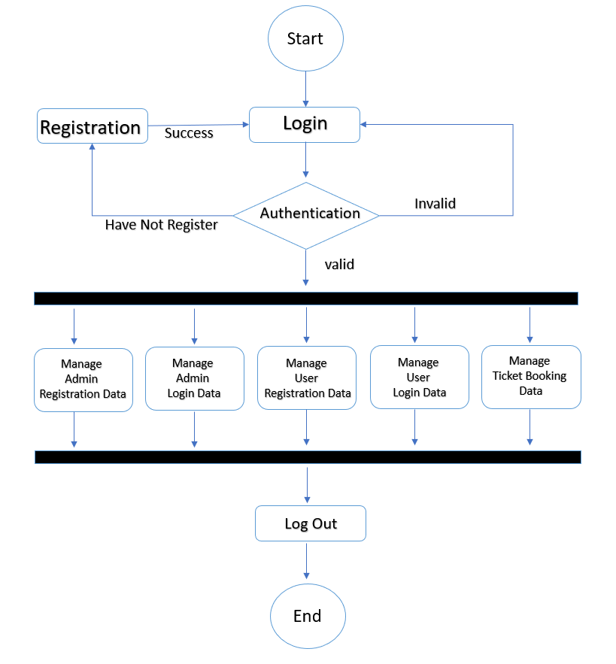

**5.4 User Activity Diagram:**

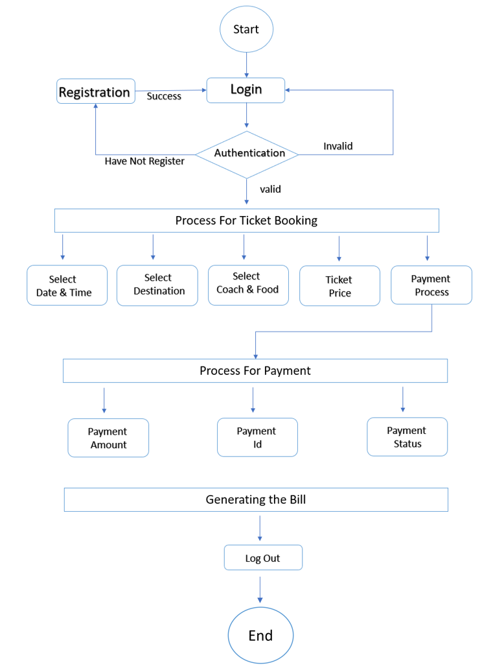

**5.5 ER Diagram**

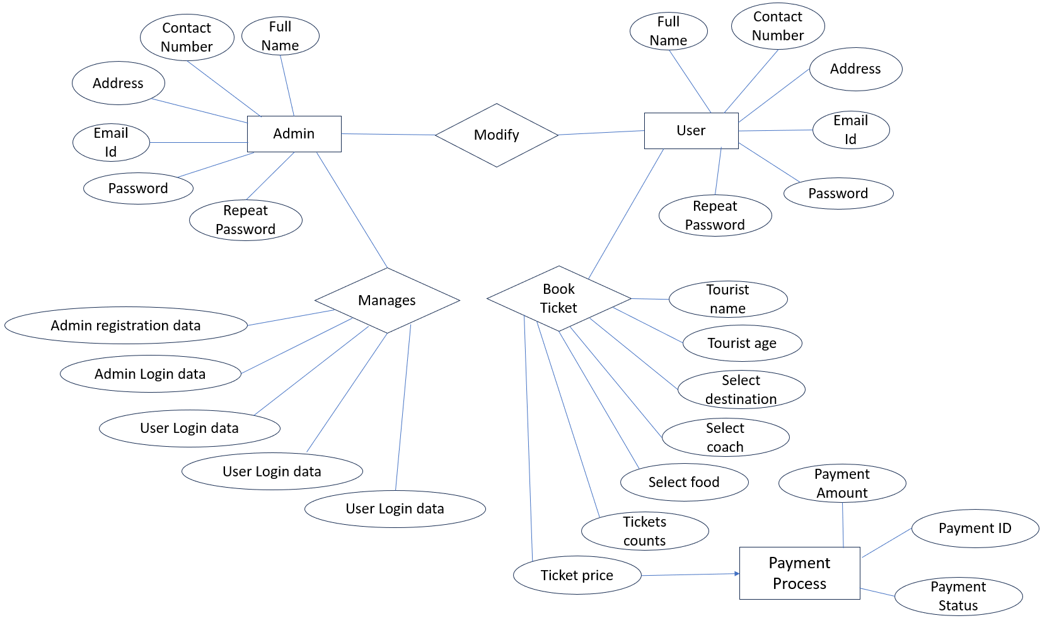

**6. System Flow Chart**

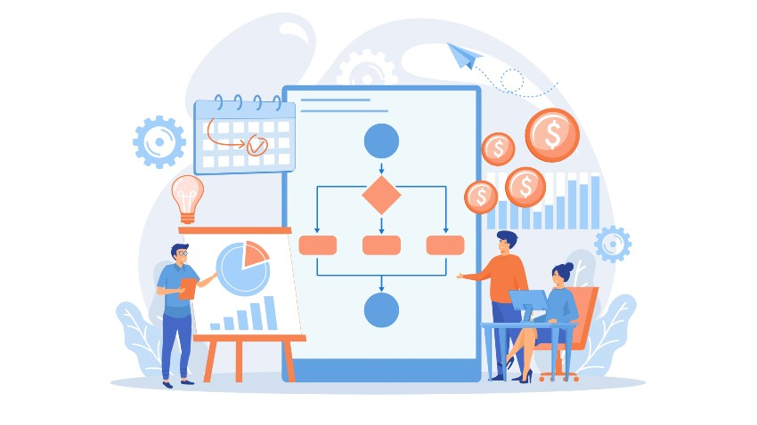

**Screenshots:**

**Admin Registration & Login:**

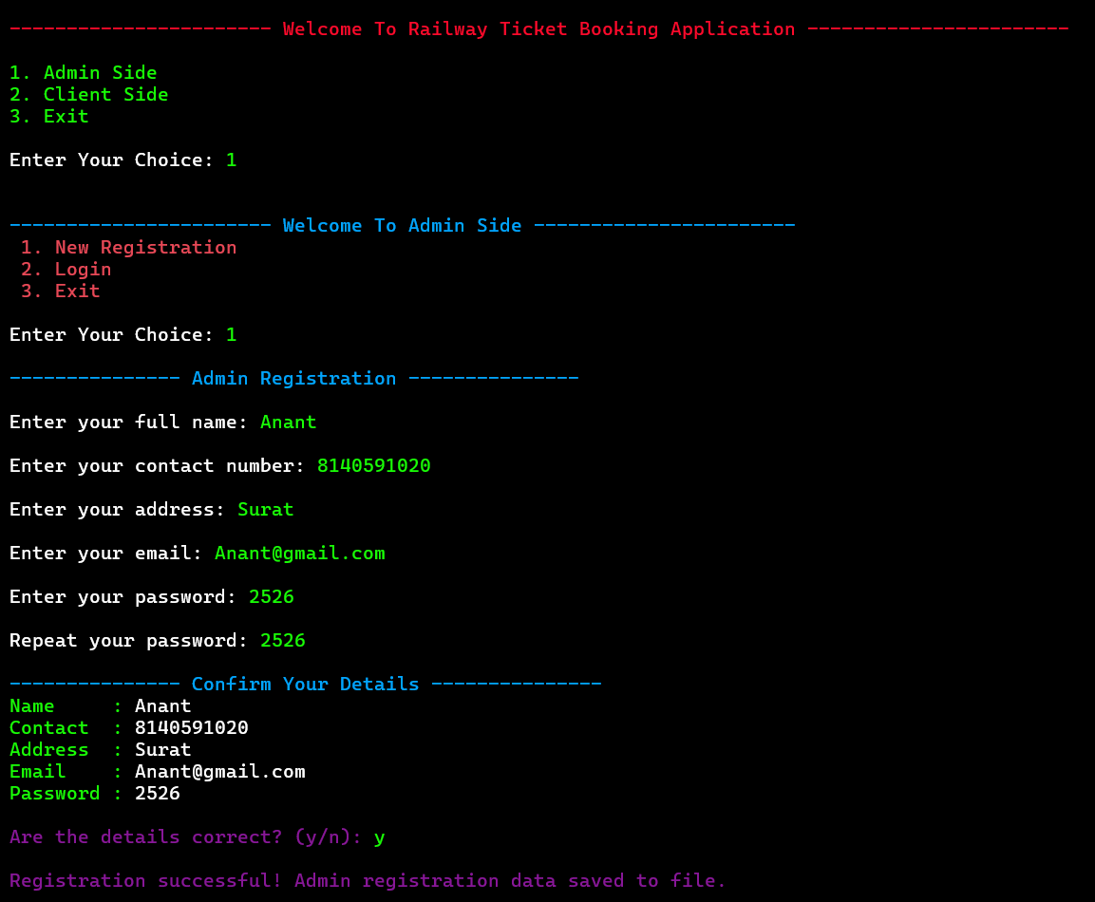

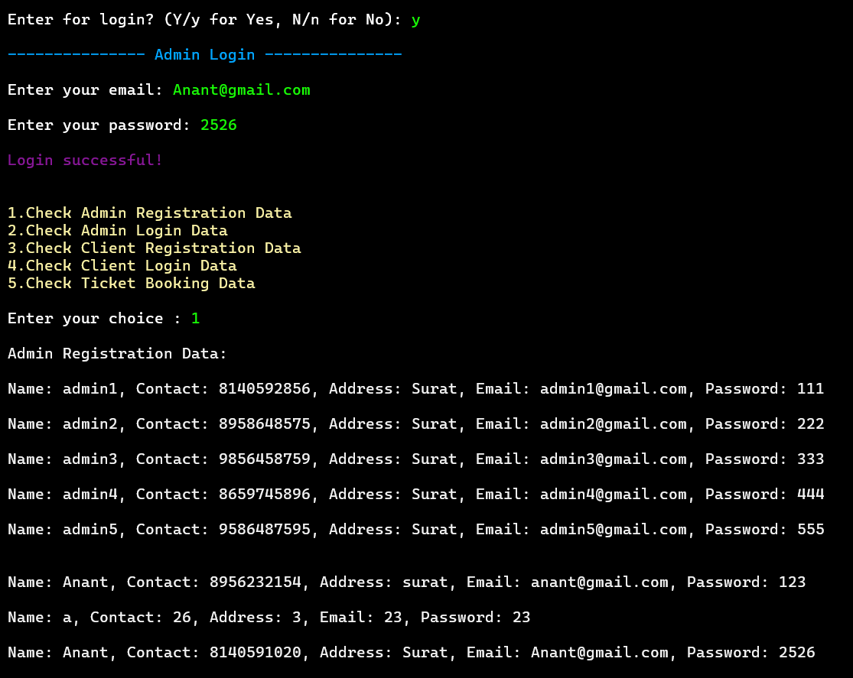

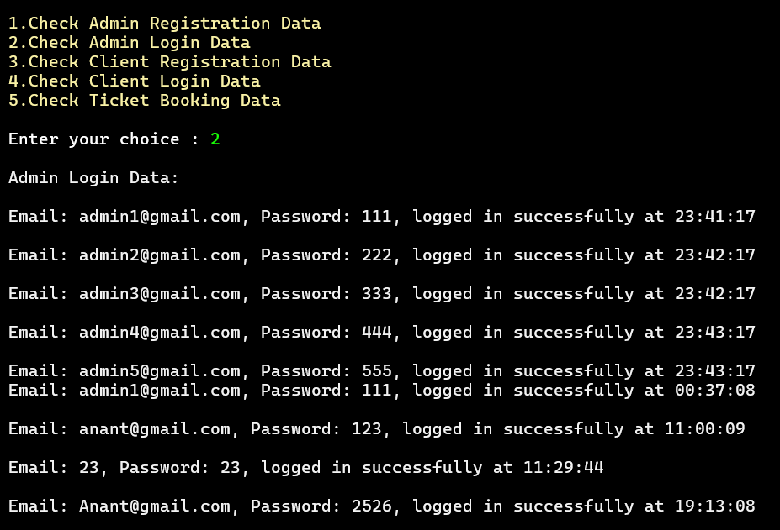

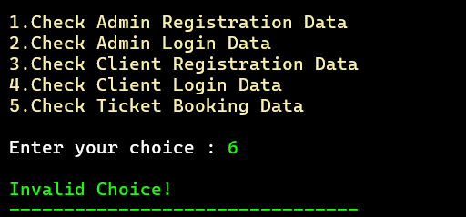

**User Registration & Login:**

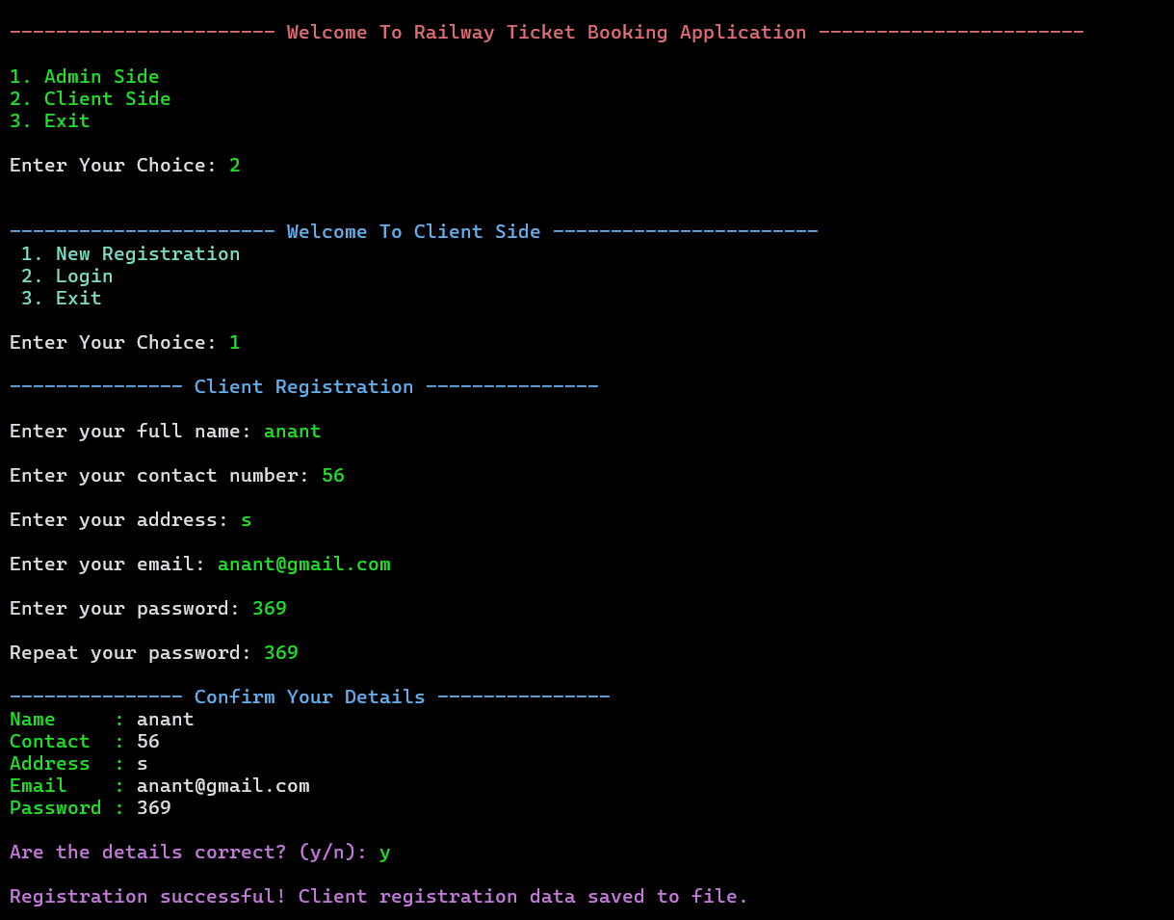

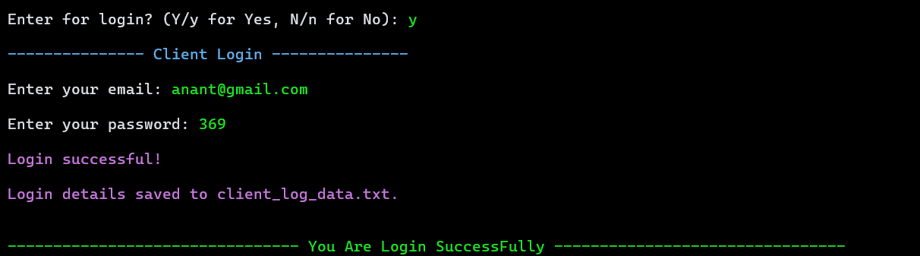

**Ticket Booking Process:**

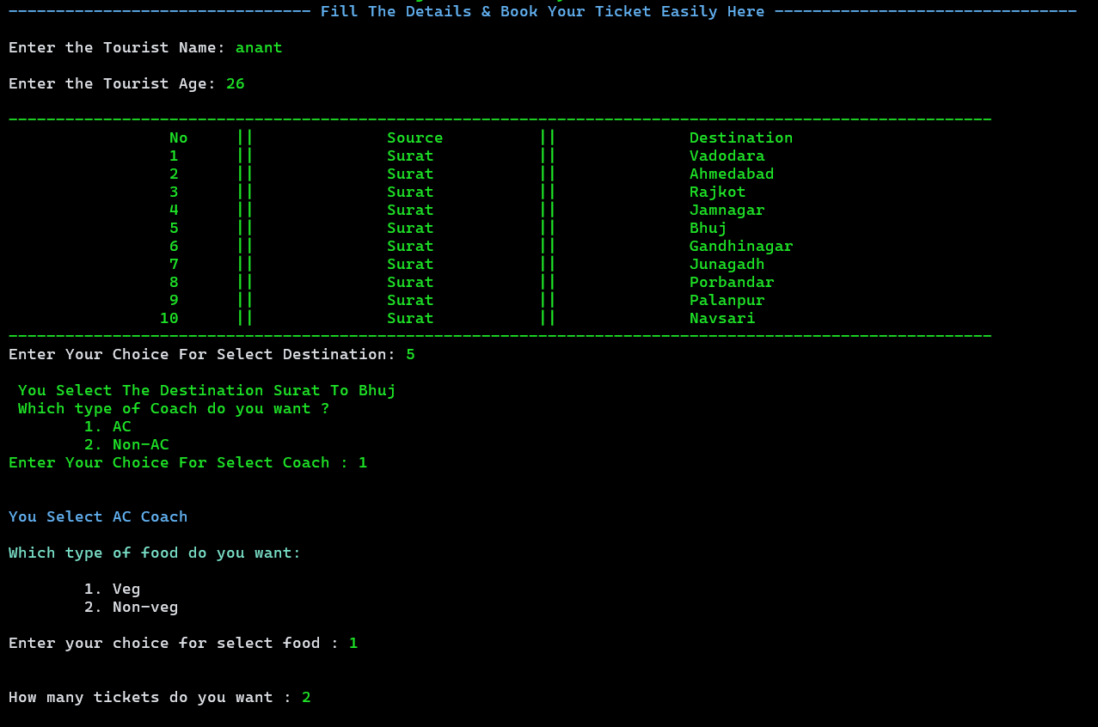

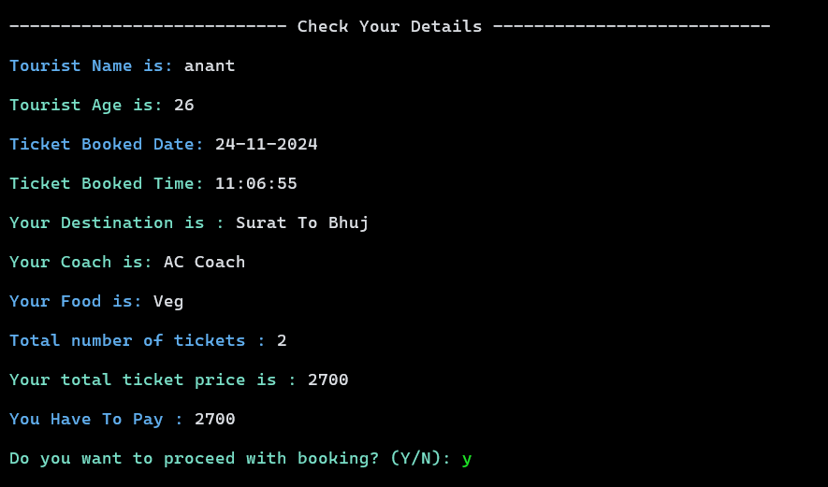

**Ticket Generated:**

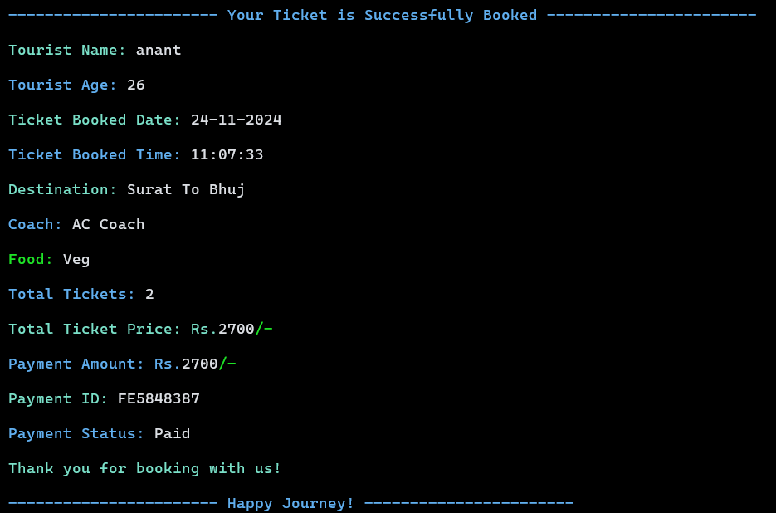

**7. Source Code**



**8. Testing**



**9. References**

* + - www.studytonight.com
    - www.drawio.com
    - www.cppreference.com
    - www.scaler.com/topics/c/file-handling-in-c/